

|  |  |  |
| --- | --- | --- |
| **MODULE** | **:** | CT071-3-5-3-DDAC - DESIGNING & DEVELOPING CLOUD APPLICATIONS |
| **STUDENT NAME** | **:** | NG SHAN MEN |
| **STUDENT ID** | **:** | TP037190 |
| **INTAKE CODE** | **:** | UC3F1701SE |
| **LECTURER** | **:** | DR. KALAI ANAND RATNAM |
| **HAND OUT DATE** | **:** | 20TH JULY 2017 |
| **HAND IN DATE** | **:** | 9TH OCTOBER 2017 |
| **COURSEWORK TITLE** | **:** | ONLINE FLIGHT BOOKING SYSTEM |

Table of Contents

1. Introduction 3

1.1 Project Background 3

1.2 Project Objectives 3

1.3 Project Deliverables 3

2. Project Plan 5

3. Design 7

3.1 Modelling 7

3.1.1 Use case 7

3.1.2 Sequence Diagram 8

3.1.3 ER Diagram 11

3.2 Design Considerations 12

3.3 Architectural Diagram 12

4.0 Implementation 13

4.1 Development of application 13

4.2 Azure Publishing 16

4.3 Application Scaling 17

5.0 Testing 20

5.1 Unit Testing 20

5.1.1 Register 20

5.1.2 Login 21

5.1.3 Home Page 22

5.1.4 Search Flight 23

5.1.5 Make Booking 24

5.1.6 View Booked Flights 25

5.1.7 View Booked Flight Detail 25

5.2 Performance Testing 26

5.1.2 Performance Testing Analysis 29

6.0 Conclusion 30

7.0 References 31

8.0 Appendix 33

# Introduction

## Project Background

Ukraine International Airlines (UIA) is the flagship carrier and largest airline in Ukraine. It operates domestic and international passenger flights and cargo services to Europe, the Middle East, the United States, and Asia. The airline is eager to expand its services provided to new markets around the world, but problems with its website prevented it from adequately serving customers beyond Ukraine. The website had also experienced denial of service (DOS) attacks, which hurts the performance and reliability of the website.

Ukraine International Airlines (UIA), is looking to design and develop an Online Flight Booking System, they have both looked at Microsoft Azure and Amazon Web Services and made a decision to choose Azure. Due to the reason of Ukraine International Airlines is looking to expand their market, they will have to ensure the availability and the performance of the system.

## Project Objectives

The objectives of the project Online Flight Booking System for Ukraine International Airlines (UIA), includes:

* To provide a system with high availability, 99.99% uptime
* To provide a system that has high performance
* To deliver a system that is user friendly

## Project Deliverables

The Online Flight Booking System for UIA will be able to accessed through many common used browsers including: Google Chrome, Mozilla Firefox and etc. The system is aim to delivered to all the potential customers worldwide and the system provides the functions such as:

* Log in and log out of the system
* Able to search for flights through origin and destination
* List all the available flights
* Booking seats for the flight
* View and print their ticket for the particular flight they book

# Project Plan

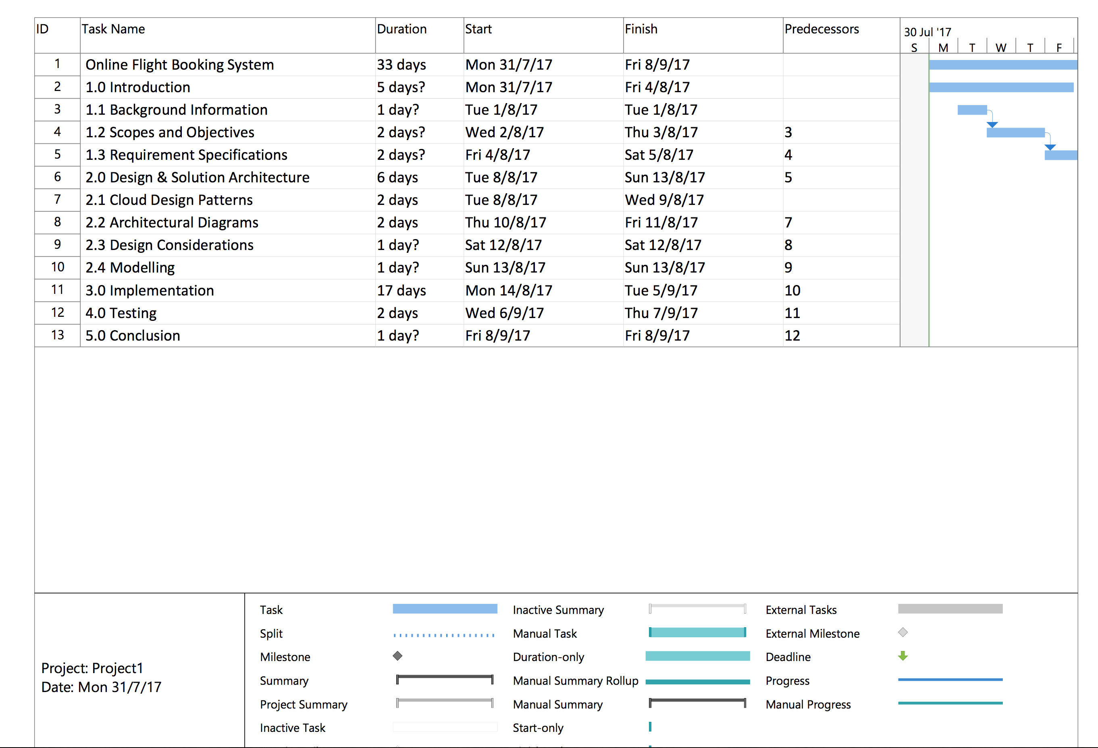

*Figure 1. Project Plan*

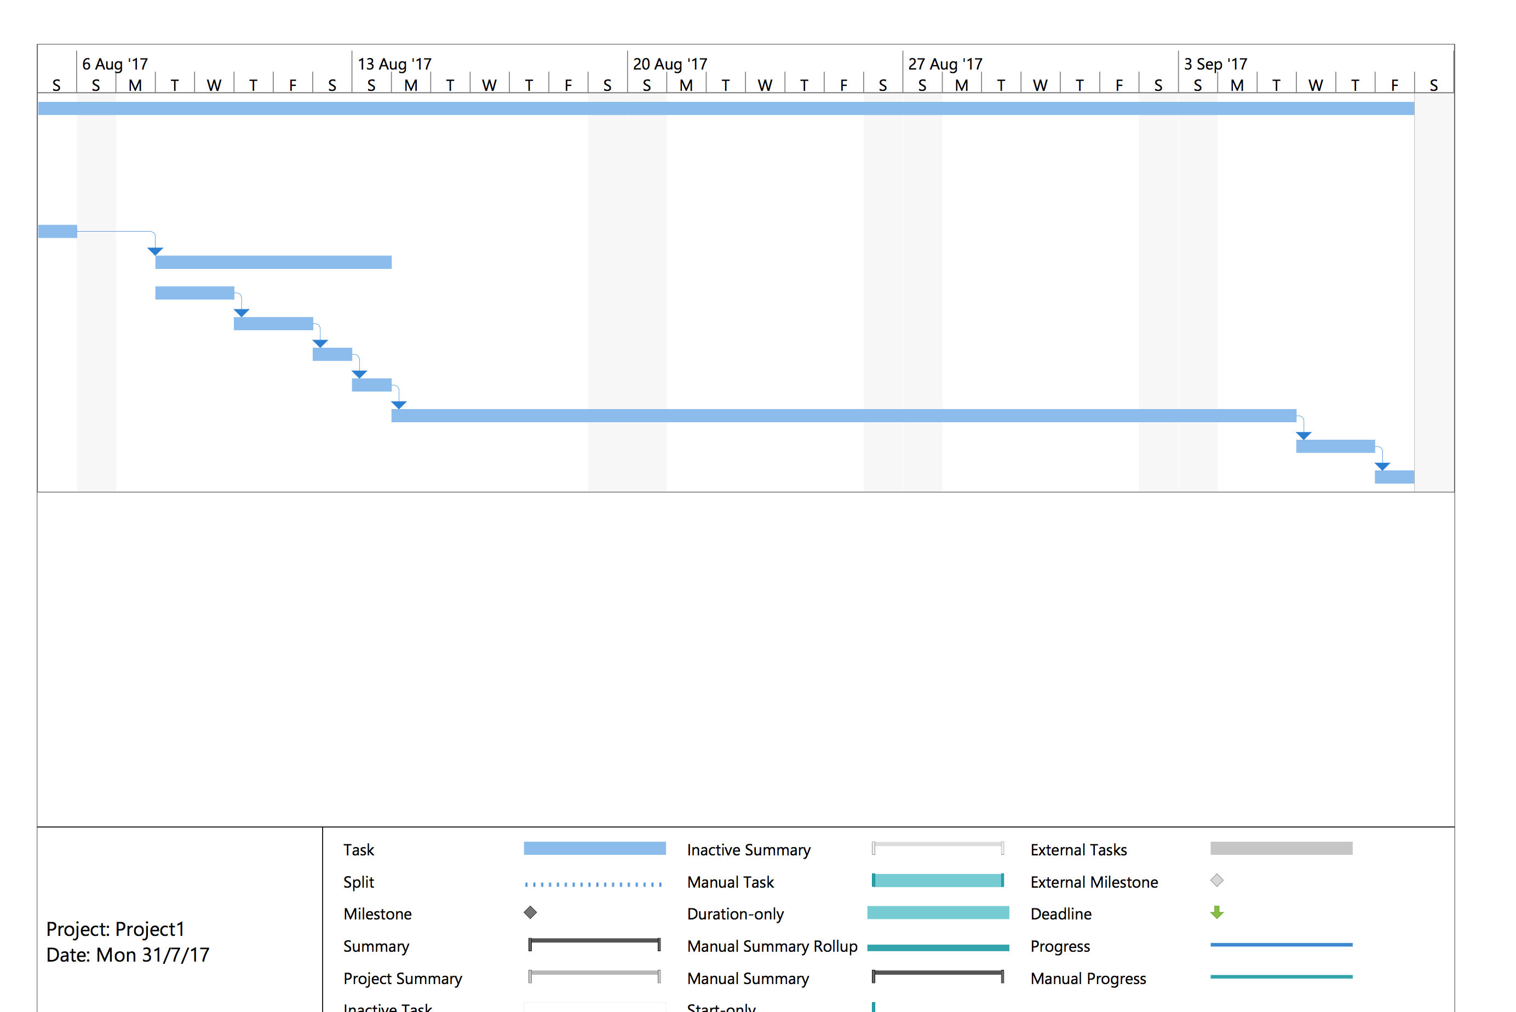

*Figure 2. Project Plan*

# Design

## 3.1 Modelling

### 3.1.1 Use case

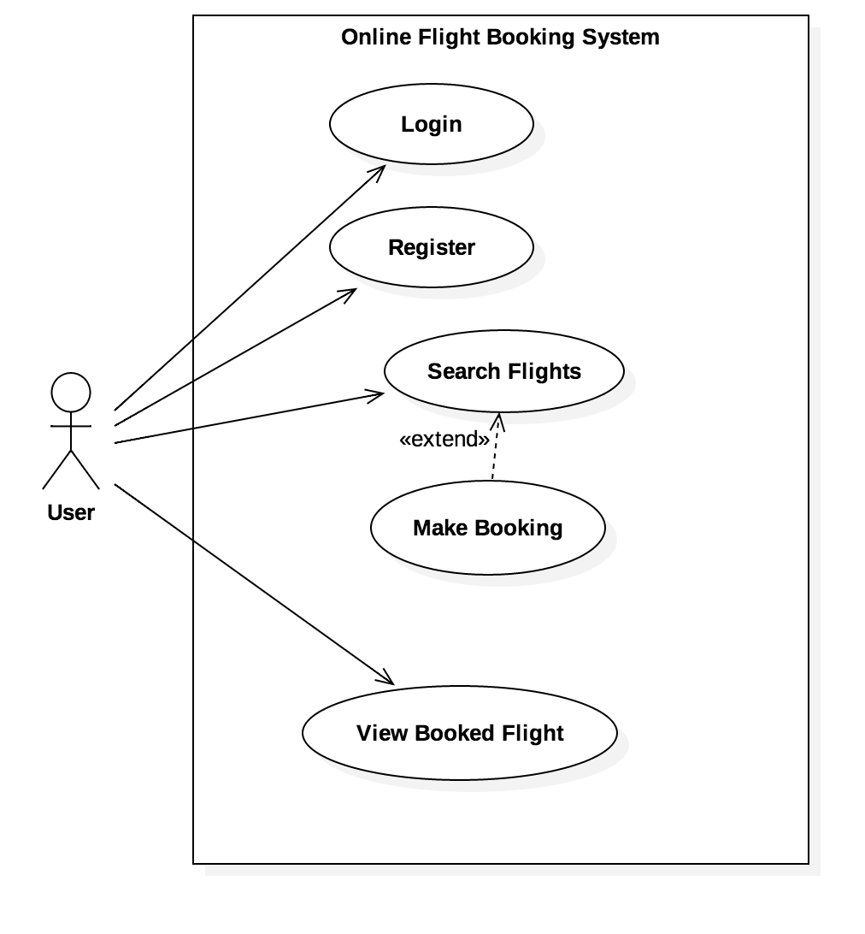

*Figure 3. Use case for online flight booking system*

The use case diagram above shows the functionalities of the end user can do, which includes login, register, search flights, make booking and view booked flight.

### 3.1.2 Sequence Diagram

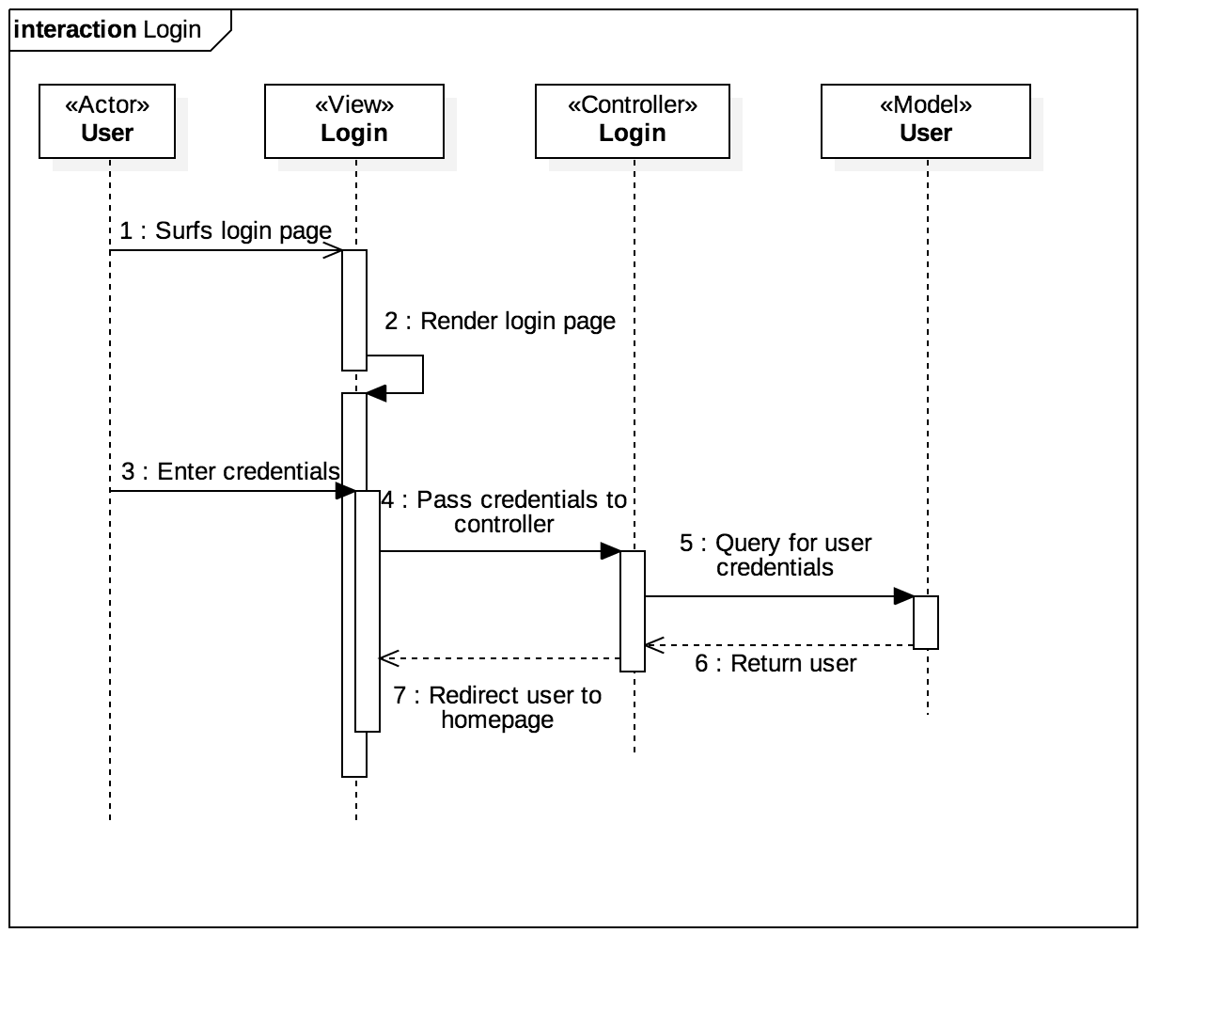

*Figure 4. Login sequence diagram.*

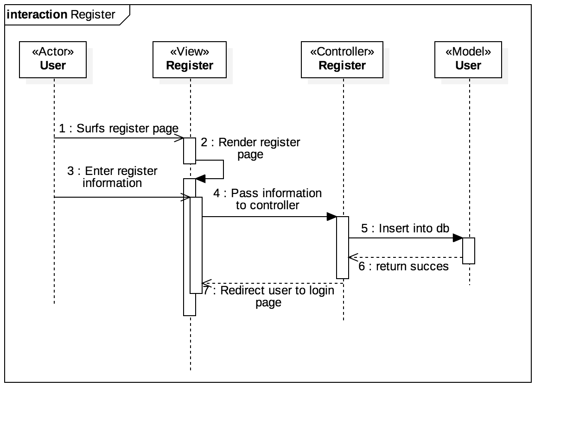

*Figure 5. Register sequence diagram.*

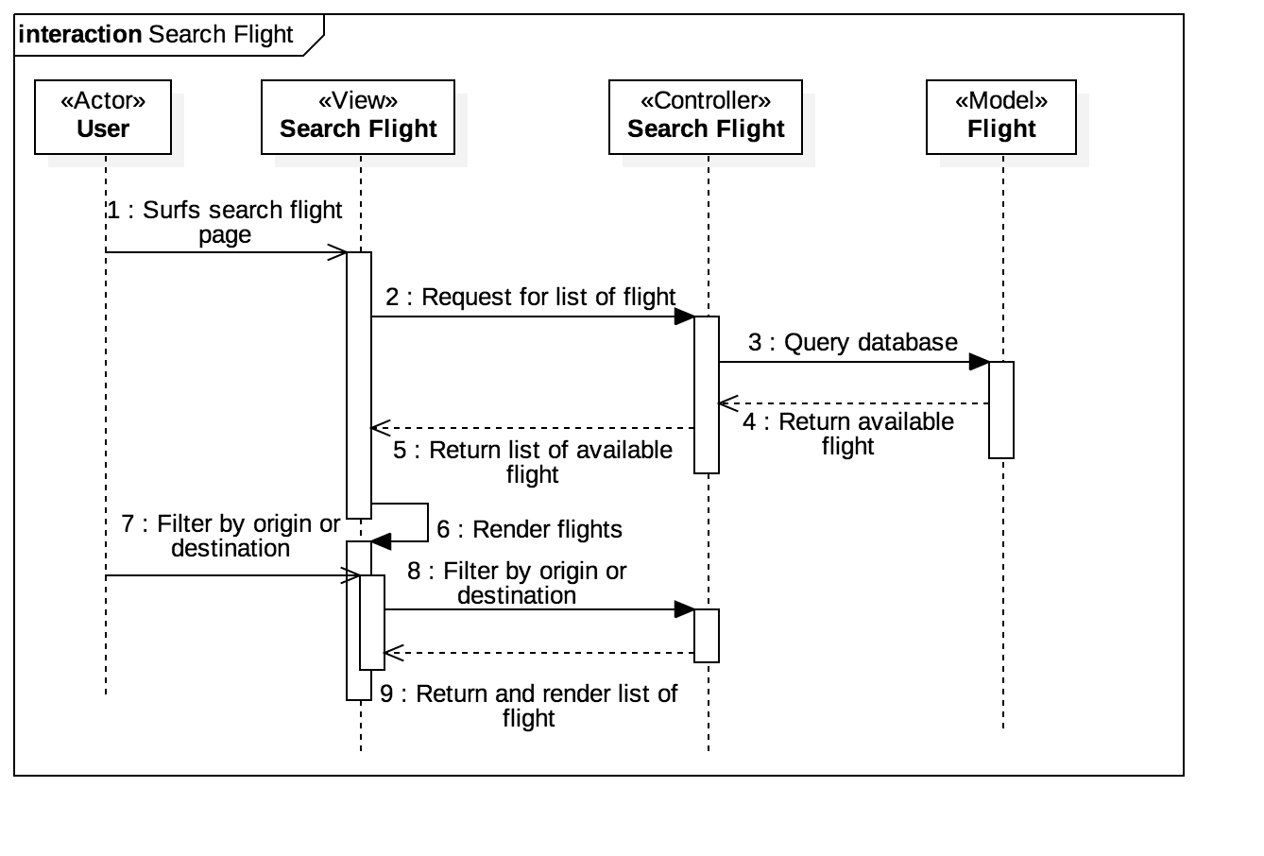

*Figure 6. Search Flight sequence diagram.*

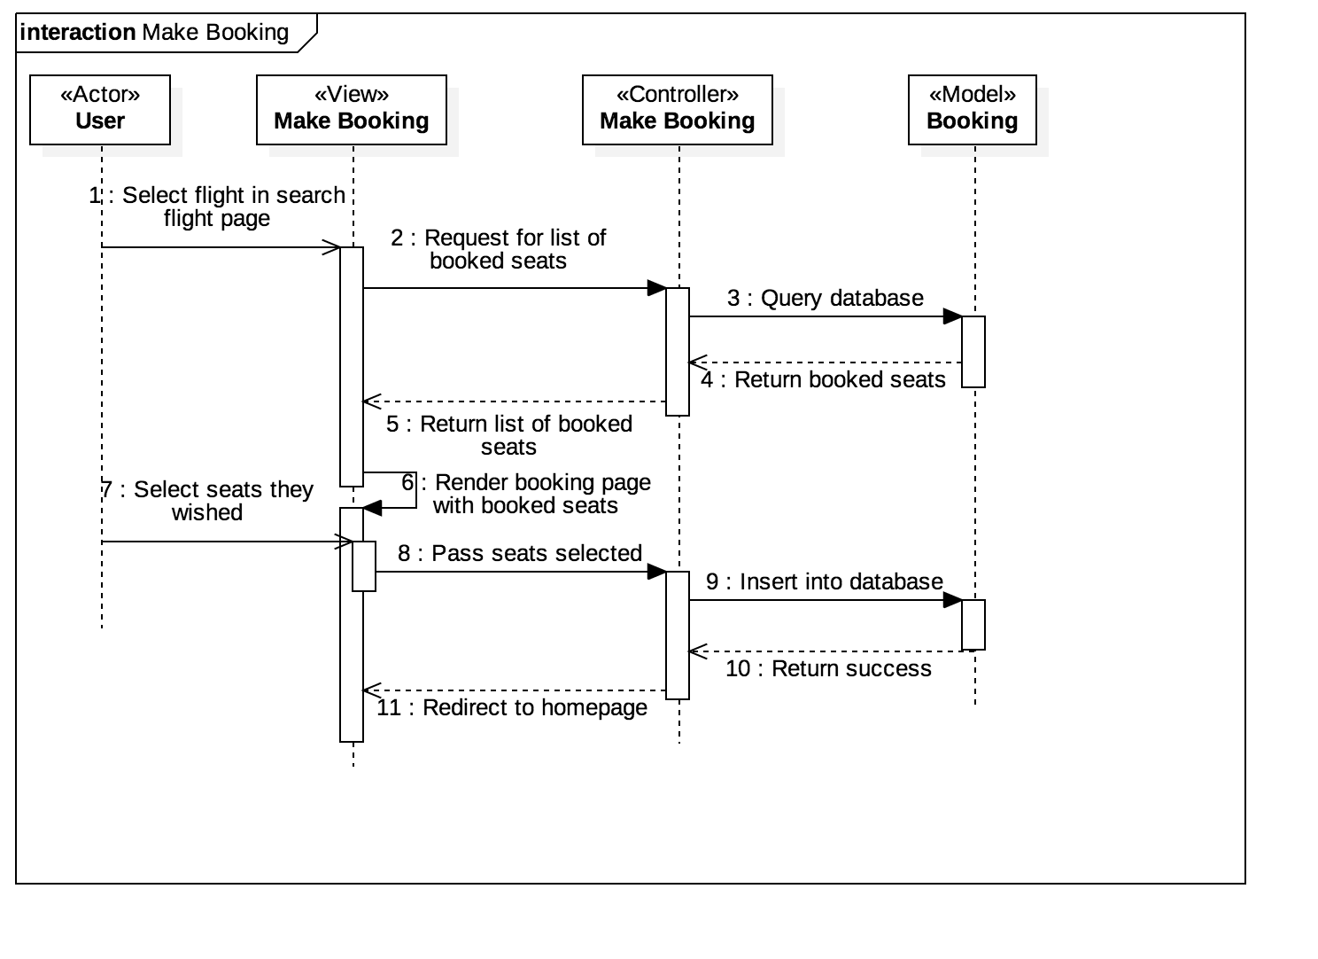

*Figure 7. Make Booking sequence diagram.*

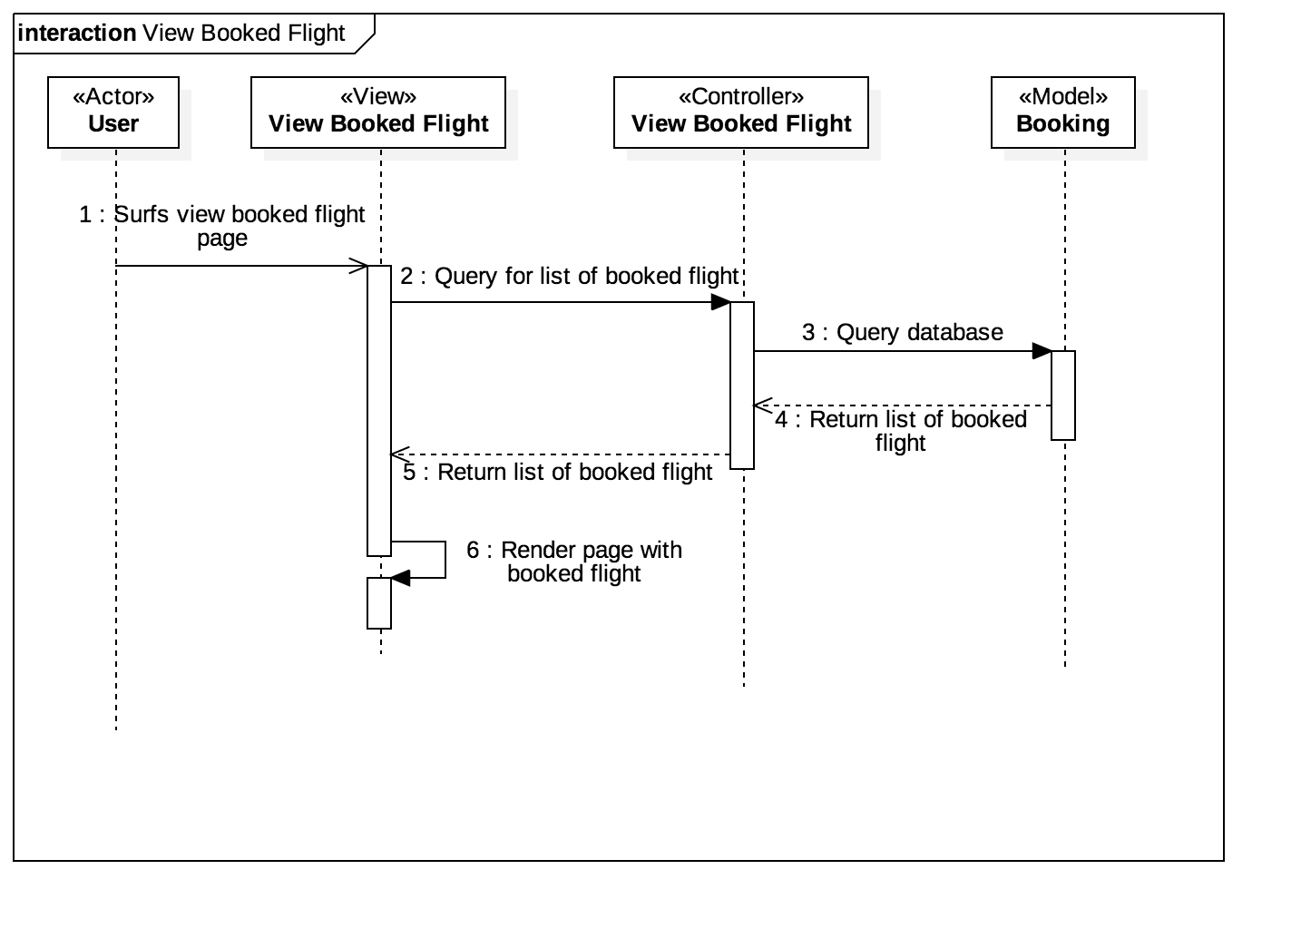

*Figure 8. View Booked Flight sequence diagram.*

### 3.1.3 ER Diagram

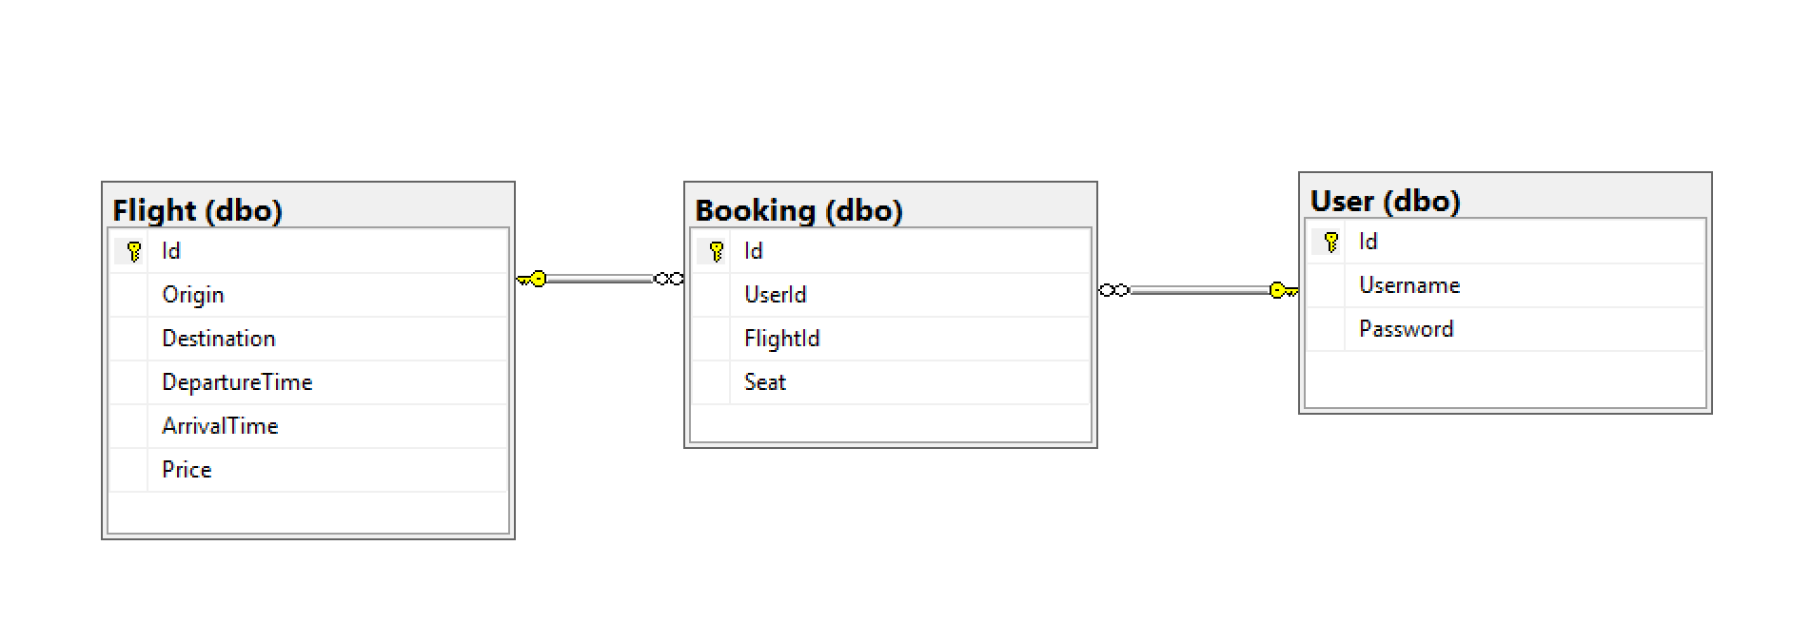

*Figure 9. ERD for online flight booking system.*

## 3.2 Design Considerations

The considerations of design have to made before moving into development, one of there is to explain their market to global, including SEA region. Therefore, the system will be deployed in SEA region, and due to the limitation of free trial credits, the team has to make good decision in order for the application to success.

## 3.3 Architectural Diagram

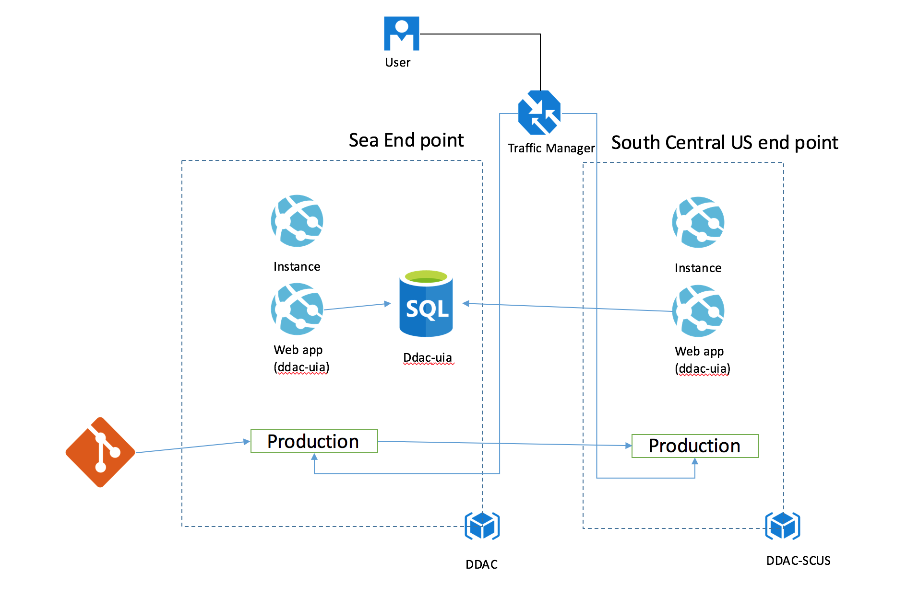

*Figure 10. Architecture diagram for the system.*

The diagram above shows the cloud architecture for the Online Flight Booking System which will be deployed to Azure. Therefore, the system is targeted to deployed to SEA, as the airline is looking to expand to other market. The system is written with MVC and MSSQL, and both of the web application uses the same database, there and any changes to GitHub will be deployed automatically to both production servers. The traffic manager is also configured to performance they will be routed to the application based on the performance of their connection which will be explained in chapter 4.

# 4.0 Implementation

## 4.1 Development of application

The online flight booking system was done using ASP. NET MVC and MSSQL as the database for this system. The structure of the system consists of three major parts of the MVC structure, Model, View and Controller. The file structure of the system is shown the image below.

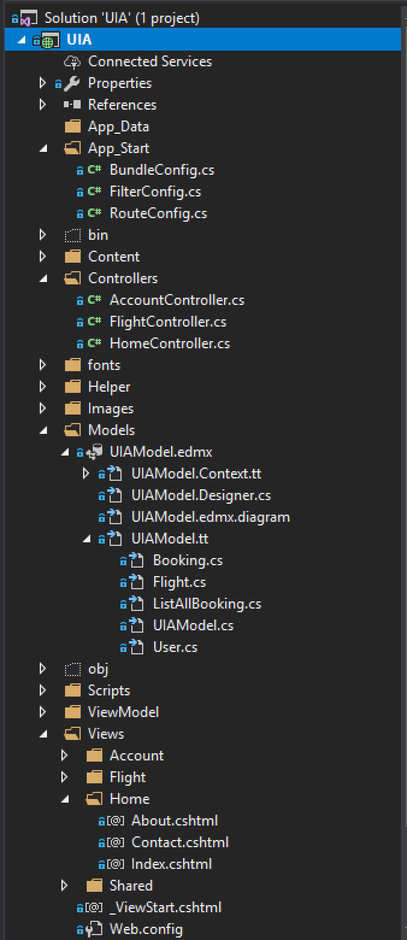

*Figure 11. File structure of the system.*

The system is start off with the route config file, it will check the url of the user entered matches which controller and what’s the method that is written in that function. All of the functions in this project will generate a view to the user. The view is what normally users see and they can perform functions in the controller, and model is the database for the system and also is a database for the system. The front-end design of the system is wrote using bootstrap, but another theme is applied to the design of the boostrap itself at the bootstrap.css file. Below are the screenshots of the system with bootstrap.

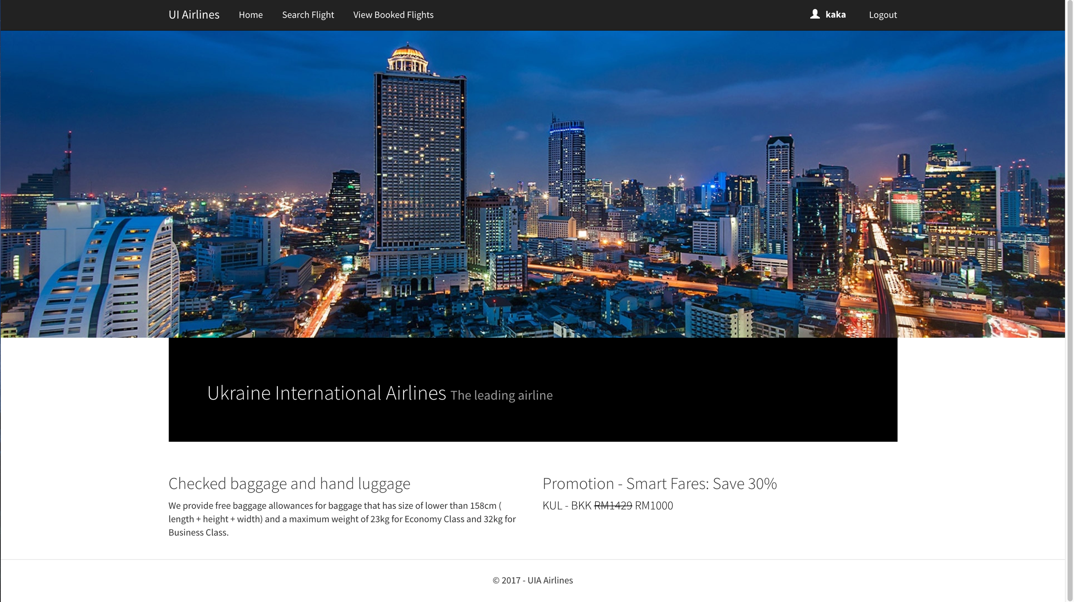

*Figure 12. The home page of system*

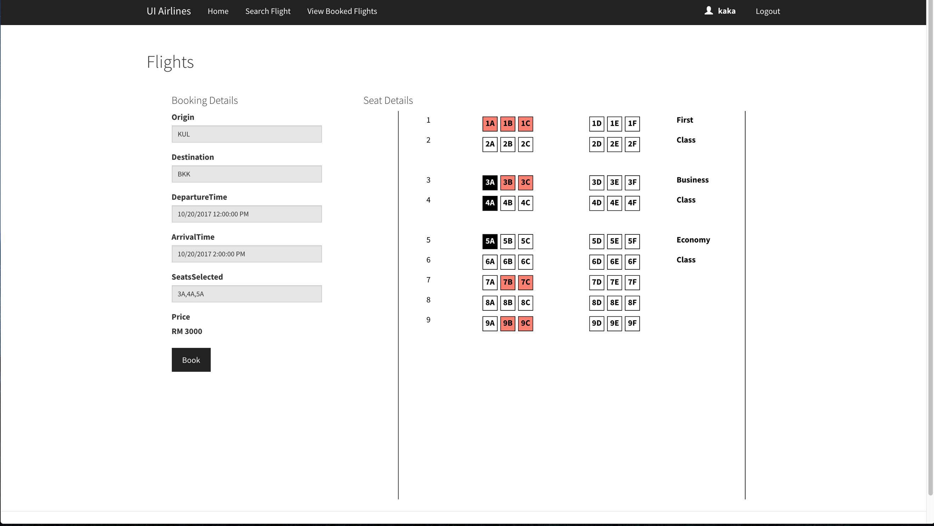

*Figure 13. The make booking page.*

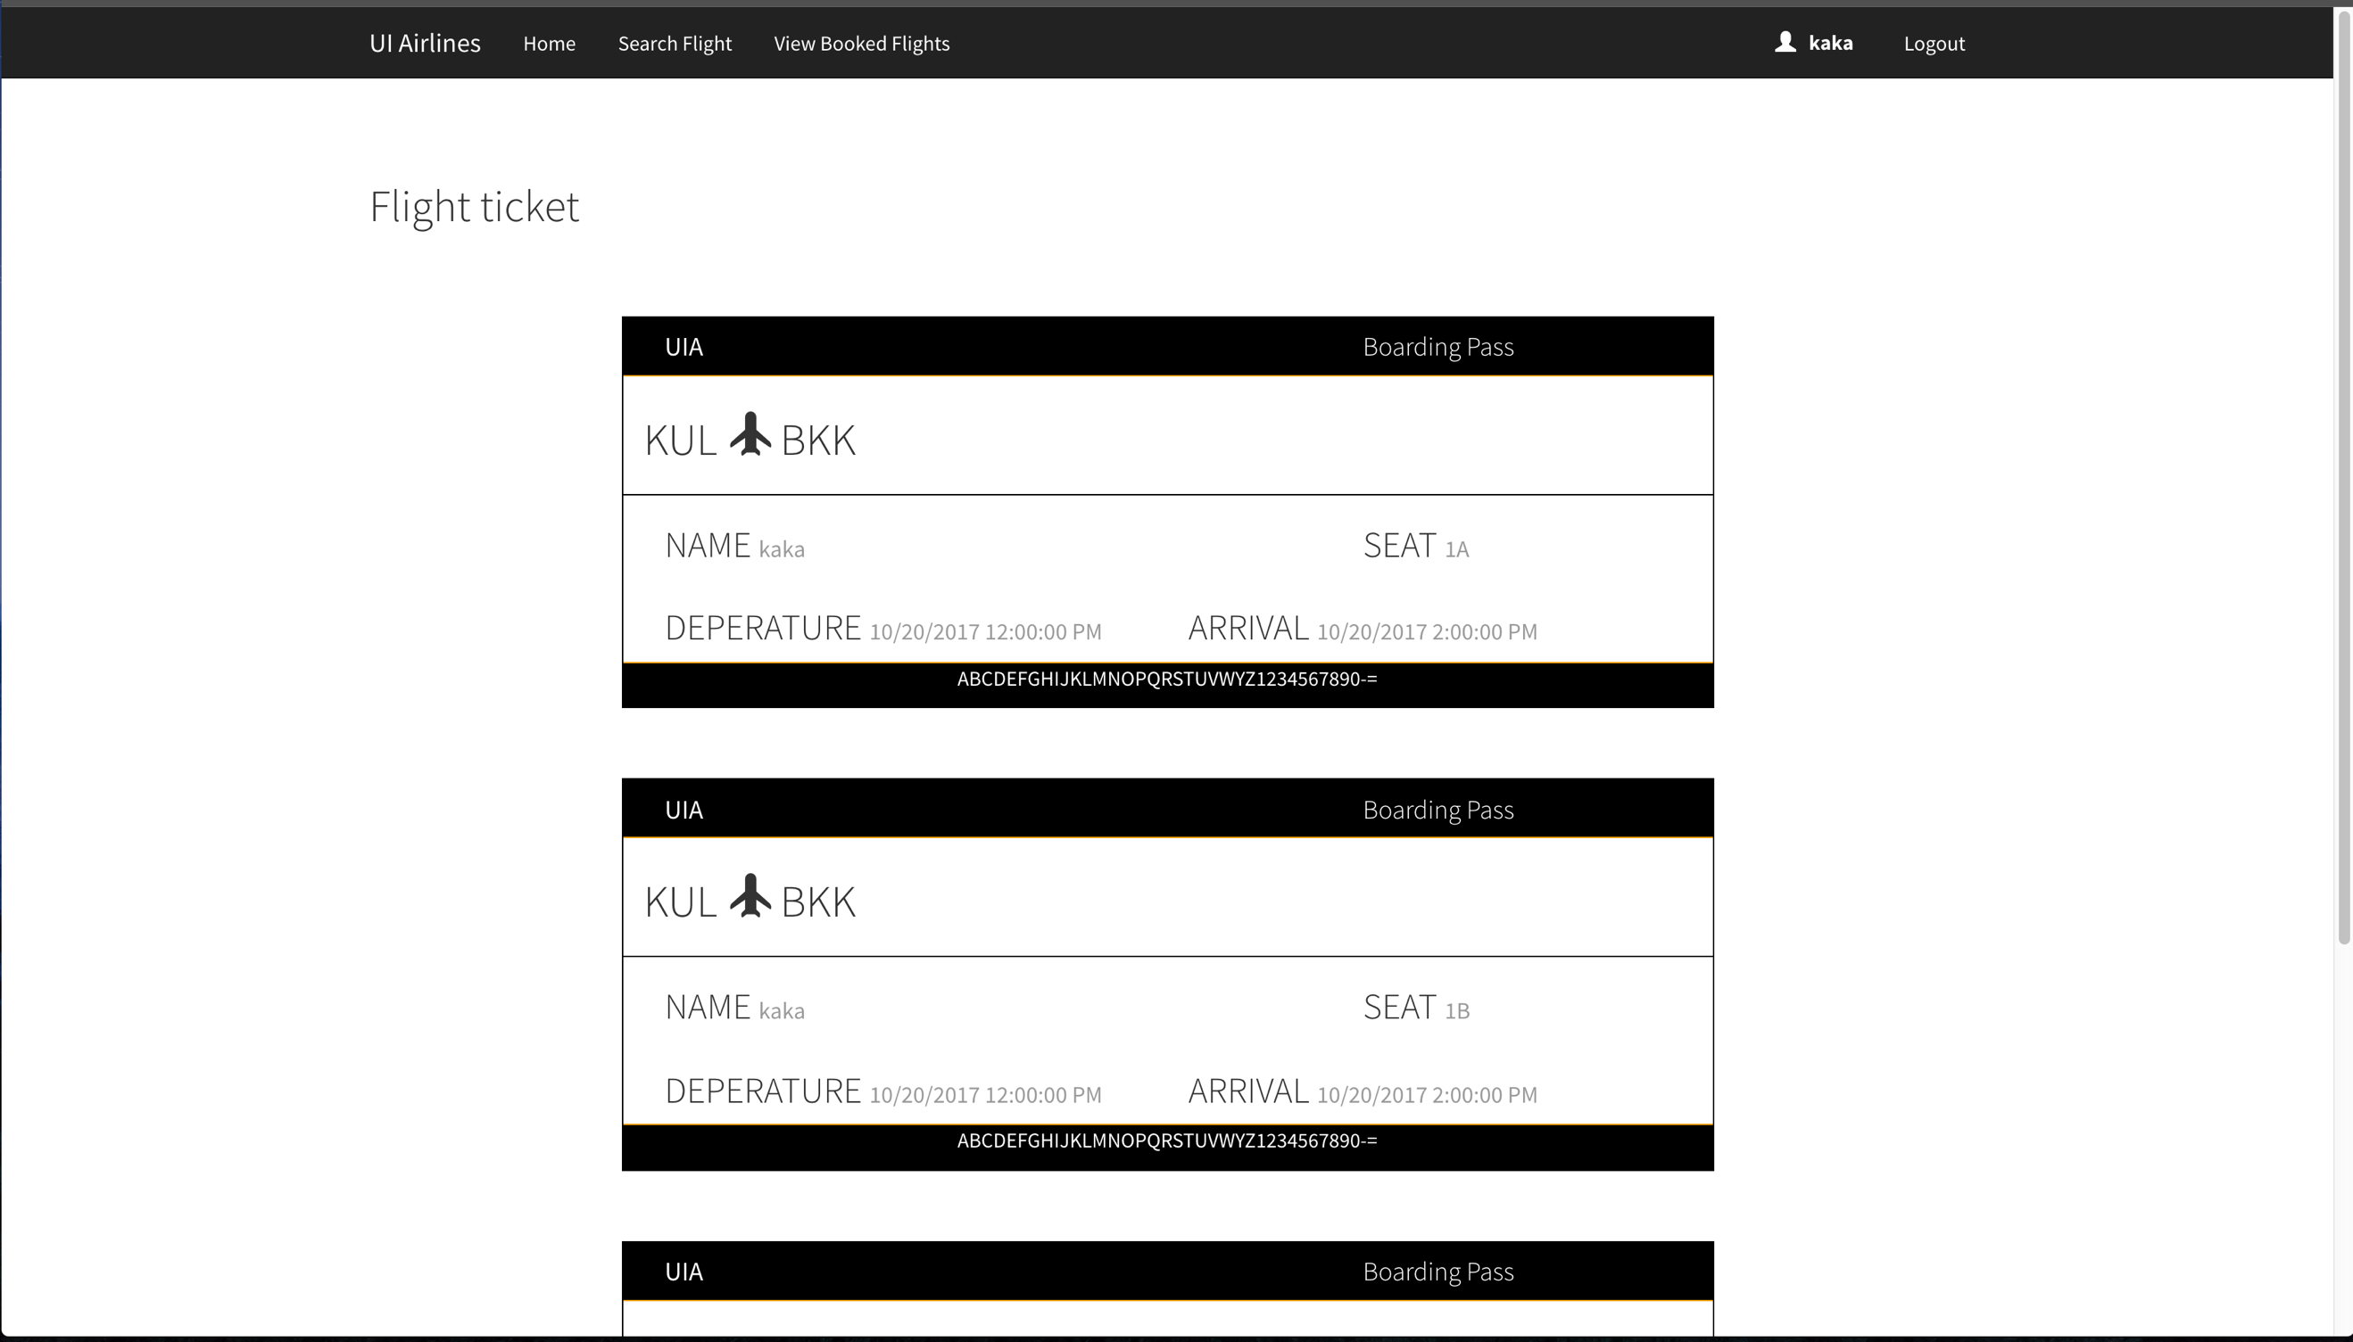

*Figure 14. Flight booking details.*

The hardest part during the development stage is to develop the seat selection in making booking page. But instead of in controller, the developer has used JQuery for the selected of seats (which indicate black) in the figure above and red colour for the seat that has been booked. The data shown above is either randomly generated or randomly inserted by the developer and deployed in to Azure. The demonstration of the system will be included into the CD as well as uploaded online, the link for the demonstration and source code is shown in the appendix section.

## 4.2 Azure Publishing

The code for the project is uploaded to the GitHub repository and the application is deployed through the automatic deployment options in Azure. All the changes that has been made into the GitHub repository will be synced automatically and deployed to Azure. Therefore, it allows the developer to speed up the development process through the integration of GitHub and Azure, as they don’t have to manually deploy the source code again. The figure below shows the method of continuous deployment through GitHub repository to Azure.

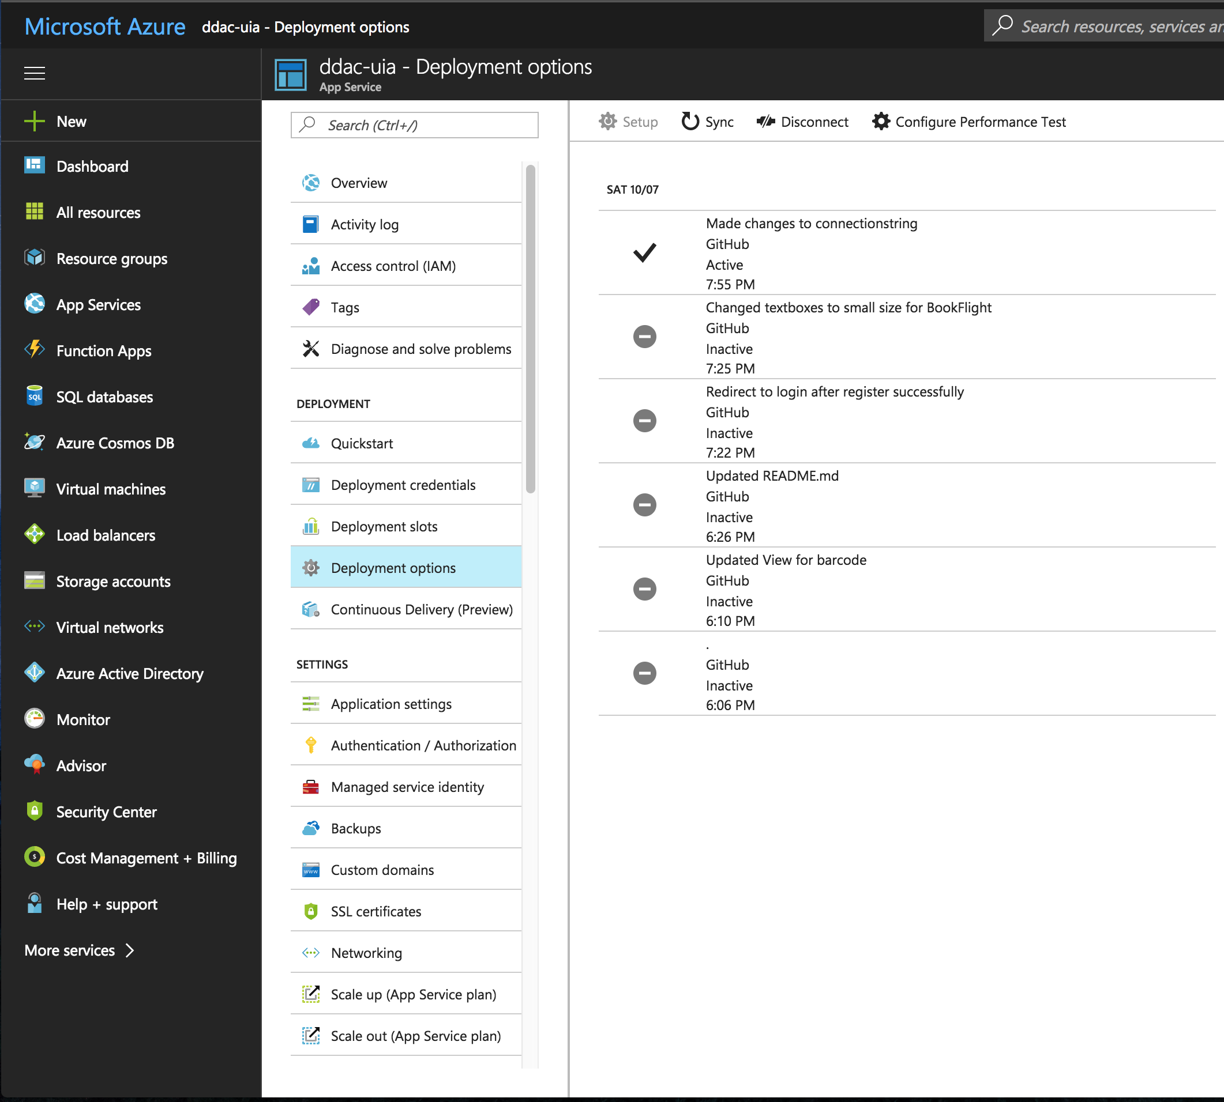

*Figure 15. The deployment options of the system.*

## 4.3 Application Scaling

The web application deployed for this project in Azure is the S1 plan. They will be deployed both at the South East Asia region and the South Central US region. The applications are deployed using the S1 due to the limited budget of the free trial account in Azure, if they have decided to push the web application to production they can upgrade to better plan to maximize the availability and performance of the system. The details of the S1 Plan is also shown below:

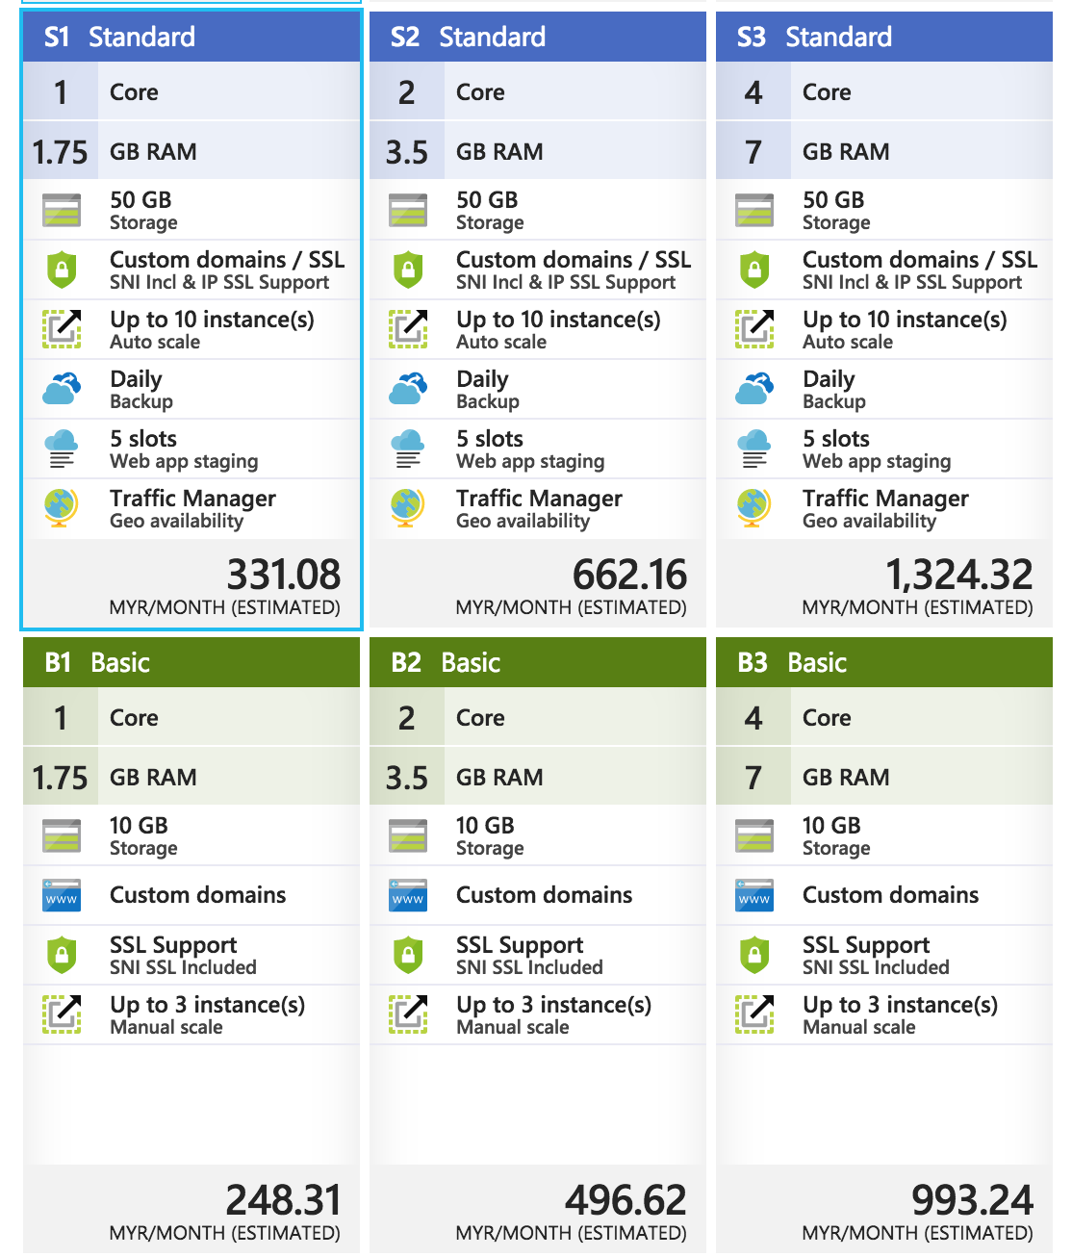

*Figure 16. Standard S1 Plan.*

Another reason of picking the S1 Plan is due to its ability to use traffic manager for the lowest price. The routing method of the traffic manager is set to performance, the performance routing method is defined by, deploying end points in two or more locations across the globe can improve the responsiveness of many applications by routing traffic to the location that is closest to you, (Microsoft, 2017). But, they have also mentioned that closest endpoint is not necessarily closest as measure by geographic distance, it is determined by the closest endpoint by measuring network latency. Therefore, in this system, there are two end points configured. The traffic manager for performance is being test through “nslookup” command, as mentioned by (Microsoft, 2017). They have also stated that the command is used to know the DNS name and IP address of the server being accessed to resolve this traffic manager domain name. (Microsoft, 2017). An example of testing is shown below:

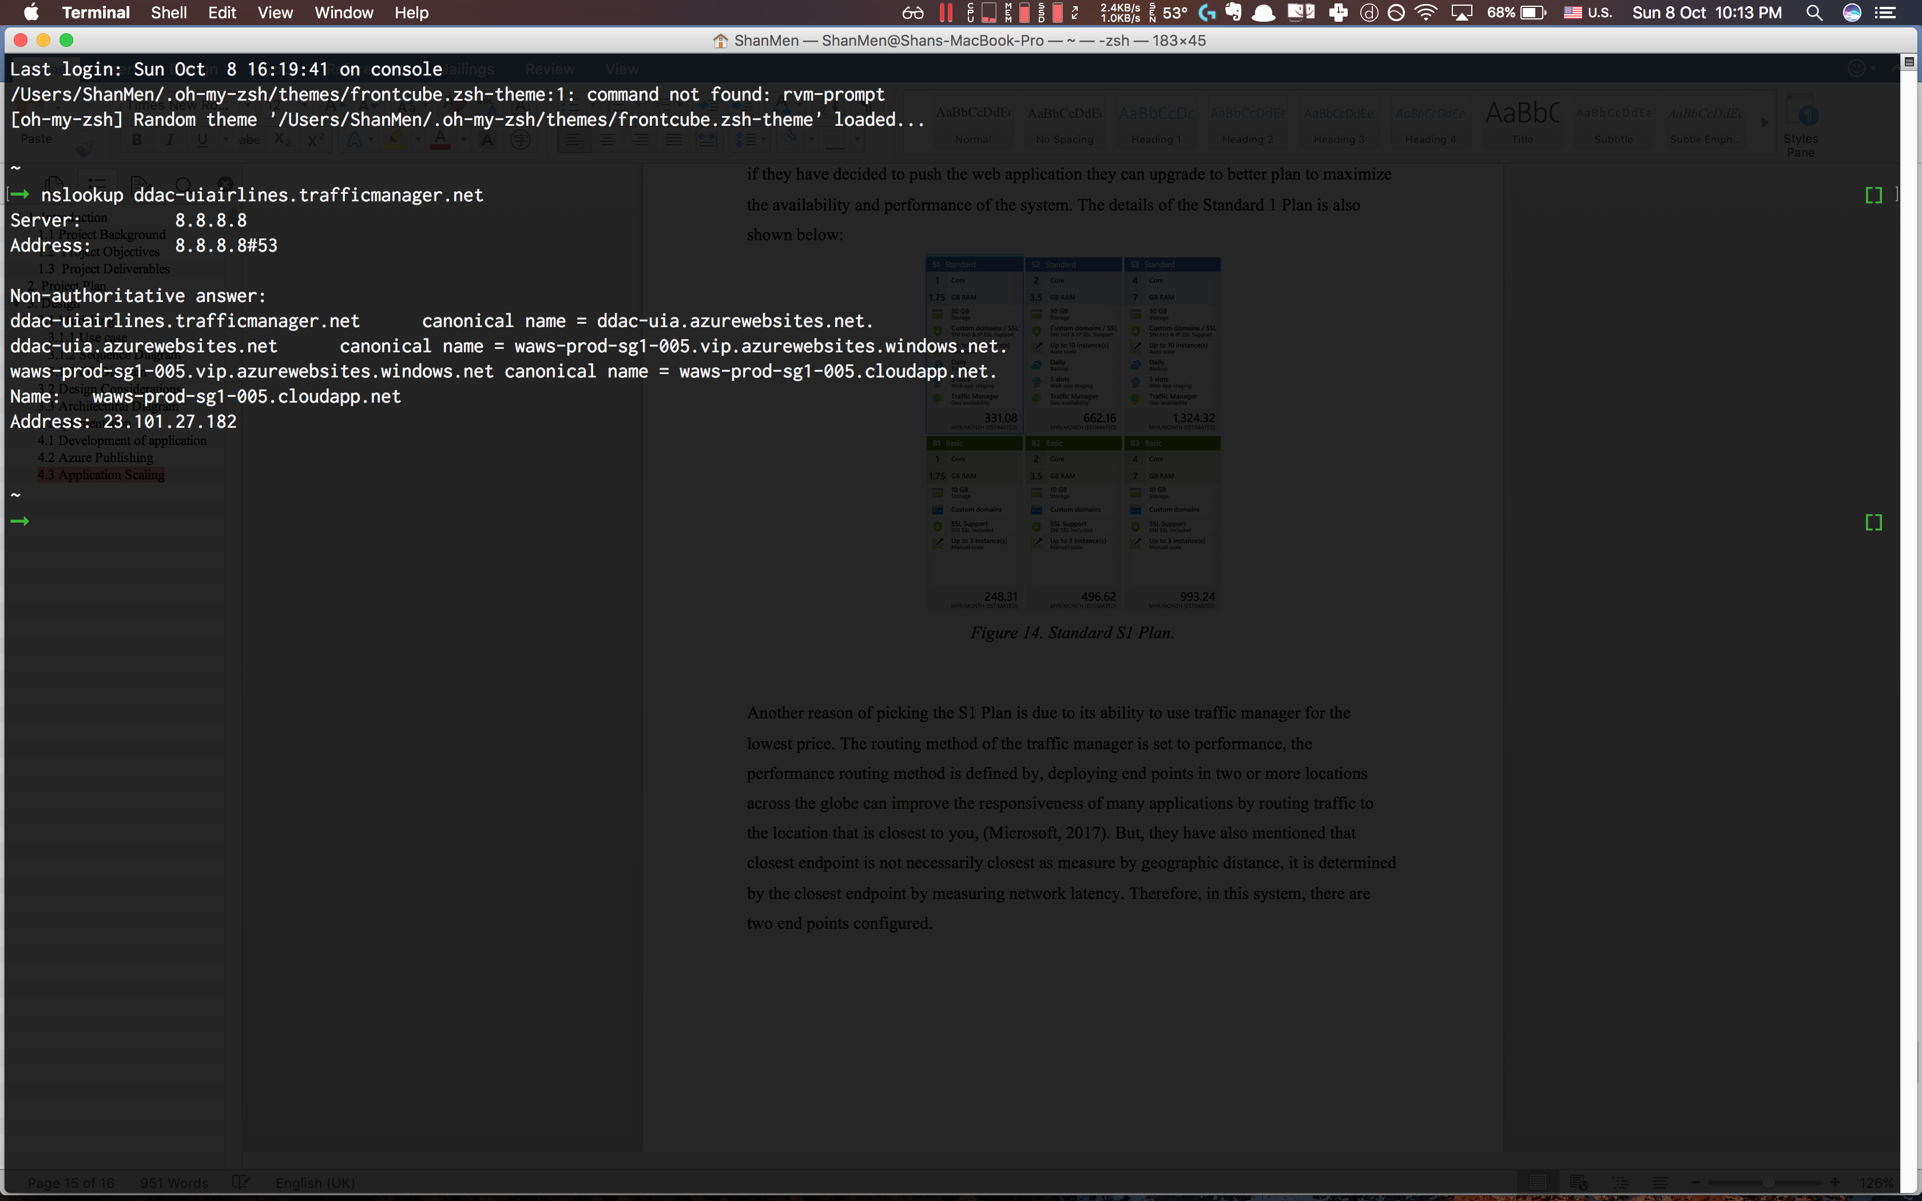

*Figure 17. Shows the command of nslookup*

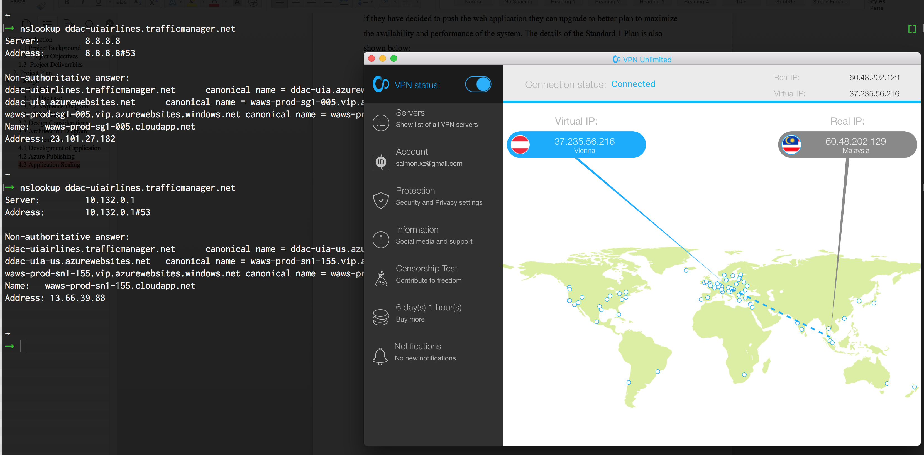

*Figure 18. Shows the command of nslookup*

The first figure shows the connecting to the traffic manager with the ddac-uia endpoint which is located in SEA and the second figure shows that when I am behind a VPN in Austria, it connects to the ddac-uia-us endpoint which is in South Central US.

Except for traffic manager, the system is also configured to scale out when the CPU usage percentage reaches 70%, it will then fire another instance and when the CPU usage reaches below 40% it will scale in, which is decrease the instance. As stated by B. Tardiff (2013), a scale out operation is the equivalent of creating multiple copies of the website and adding load balancer to distribute the demand between them.

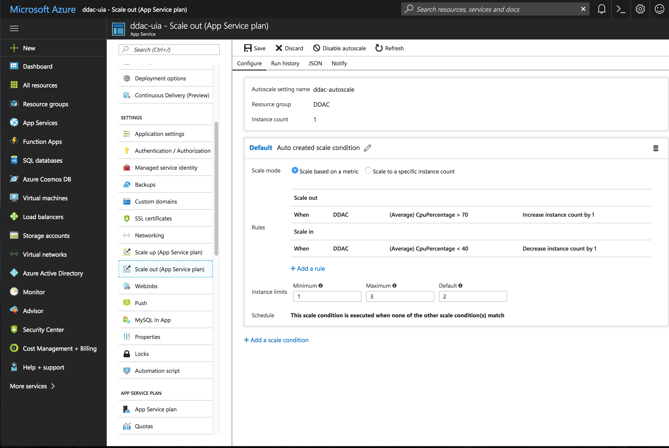

*Figure 19. The scale out of the system.*

# 5.0 Testing

## 5.1 Unit Testing

### 5.1.1 Register

|  |  |  |  |  |  |
| --- | --- | --- | --- | --- | --- |
| **Test Element** | **Test Case ID** | **Test Condition** | **Description** | **Expected Result** | **Actual Result** |
| Register | A001 | Username: admin  Password: admin  Confirm Password: admin | User fills up all the required fields and in valid pattern and press register. | User should be redirected to login page. | User should be redirected to login page. |
| Register | A002 | Username: admin  Password: admin  Confirm Password: admin | User enters a username that has been registered. | Message saying “Username is already taken” will be shown. | Message saying “Username is already taken” will be shown. |
| Register | A003 | Username: admin  Password: admin  Confirm Password: admin2 | User enters a different password and confirm password. | Message saying “Password and confirm password doesn’t match” will be shown. | Message saying “Password and confirm password doesn’t match” will be shown. |
| Register | A004 | - | User clicks on “Have an account? Click here”. | User will be redirected to login page. | User will be redirected to login page. |

### 5.1.2 Login

|  |  |  |  |  |  |
| --- | --- | --- | --- | --- | --- |
| **Test Element** | **Test Case ID** | **Test Condition** | **Description** | **Expected Result** | **Actual Result** |
| Login | B001 | Username: admin  Password: admin | User fills up all the required fields and in valid pattern and press login. | User should be redirected to home page. | User should be redirected to home page. |
| Login | B002 | Username: admin  Password: admin | Users enter a combination of wrong credentials. | Message saying “Incorrect credentials” will be shown. | Message saying “Incorrect credentials” will be shown. |
| Login | B003 | Username: {empty}  Password: {empty} | User left username and password empty and press login button. | Message saying “Username is required” and “password is required” will be shown. | Message saying “Username is required” and “password is required” will be shown. |
| Login | B004 | - | User clicks on “Don’t have an account? Click here”. | User will be redirected to register page. | User will be redirected to register page. |

### 5.1.3 Home Page

|  |  |  |  |  |  |
| --- | --- | --- | --- | --- | --- |
| **Test Element** | **Test Case ID** | **Test Condition** | **Description** | **Expected Result** | **Actual Result** |
| Home Page | C001 | User is logged in to the system. | User presses one of the link “Promotion - Smart Fares: Save 30%”. | User should be redirected to make booking page with flight details entered. | User should be redirected to make booking page with flight details entered. |
| Home Page | C002 | User is logged in to the system. | User presses on “Log out” button. | User will be logged out. | User will be logged out. |
| Home Page | C003 | User is logged in to the system. | User presses on “Search Flight” button. | User will be redirected to search flight page. | User will be redirected to search flight page. |
| Home Page | C004 | User is logged in to the system. | User presses on “View Booked Flight” button. | User will be redirected to view booking list page. | User will be redirected to view booking list page. |

### 5.1.4 Search Flight

|  |  |  |  |  |  |
| --- | --- | --- | --- | --- | --- |
| **Test Element** | **Test Case ID** | **Test Condition** | **Description** | **Expected Result** | **Actual Result** |
| Search Flight | D001 | User surfs the search flight page. | User surfs the search flight page. | The page should display a list available flight. | The page should display a list available flight. |
| Search Flight | D002 | Origin: KUL (Kuala Lumpur)  Destination: BKK (Bangkok) | User selects the origin and destination and presses on search. | The page should display a list of filtered origin and destination. | The page should display a list of filtered origin and destination. |
| Search Flight | D003 | User presses one of the flight detail. | User presses one of the flight detail at the table rendered. | User will be redirected to make booking page with flight detail. | User will be redirected to make booking page with flight detail. |

### 5.1.5 Make Booking

|  |  |  |  |  |  |
| --- | --- | --- | --- | --- | --- |
| **Test Element** | **Test Case ID** | **Test Condition** | **Description** | **Expected Result** | **Actual Result** |
| Making Booking | E001 | User surfs the search flight page and select one of the flight from the list. | User surfs the search flight page and select one of the flight from the list. | The page should display the flight details and seat that is booked. | The page should display the flight details and seat that is booked. |
| Making Booking | E002 | User presses on booked seat. | User presses on seat that has been booked by the others. | The system should prohibit the user to press on booked seat. | The system should prohibit the user to press on booked seat. |
| Making Booking | E003 | User presses on their seat they wish to book. | User presses one of the flight detail at the seats rendered and proceed to book. | User will be redirected to “View booked flight page”. | User will be redirected to “View booked flight page”. |

### 5.1.6 View Booked Flights

|  |  |  |  |  |  |
| --- | --- | --- | --- | --- | --- |
| **Test Element** | **Test Case ID** | **Test Condition** | **Description** | **Expected Result** | **Actual Result** |
| View Booked Flight | F001 | User surfs the view booked flight page. | User surfs the view booked flight page. | The page should display a list of booking that has been my by the user. | The page should display a list of booking that has been my by the user. |
| View Booked Flight | F002 | User presses on one of the booking. | User presses on one of the booking. | The should be redirected to “Booking Flight Detail Page”. | The should be redirected to “Booking Flight Detail Page”. |

### 5.1.7 View Booked Flight Detail

|  |  |  |  |  |  |
| --- | --- | --- | --- | --- | --- |
| **Test Element** | **Test Case ID** | **Test Condition** | **Description** | **Expected Result** | **Actual Result** |
| View Booked Flight Detail | G001 | User surfs the view booked flight details redirected from view booked flight page. | User surfs the view booked flight details redirected from view booked flight page. | The page should display a list of flight tickets of the user booked. | The page should display a list of flight tickets of the user booked. |
| View Booked Flight Detail | G002 | User presses on back button. | User presses on back button. | The user should be redirected back to “View Booked Flight” page. | The user should be redirected back to “View Booked Flight” page. |

## 5.2 Performance Testing

The performance test of the web app is conducted 6 times, from 250 concurrent users to 500 and to 750 concurrent users, the duration of the test is set to 5 minutes, and was tested 8th October 2017. From 5pm to 9pm which is the peak hour of users for SEA region. Below is the table of the result from performance testing.

|  |  |  |  |  |
| --- | --- | --- | --- | --- |
| Test | | | Result | |
| **Test Name** | **Start Time** | **Target Load** | **AVG RESP TIME(SEC)** | **REQ/SEC** |
| PerfTest01 | 08/10/2017, 17:11 | 250 | 0.15 | 443.58 |
| PerfTest02 | 08/10/2017, 17:25 | 500 | 0.48 | 660.12 |
| PerfTest03 | 08/10/2017, 17:38 | 750 | 1.2 | 629.92 |
| PerfTest04 | 08/10/2017, 18:27 | 250 | 0.16 | 441.89 |
| PerfTest05 | 08/10/2017, 19:52 | 500 | 0.48 | 668.95 |
| PerfTest06 | 08/10/2017, 21:20 | 750 | 1.16 | 625.77 |

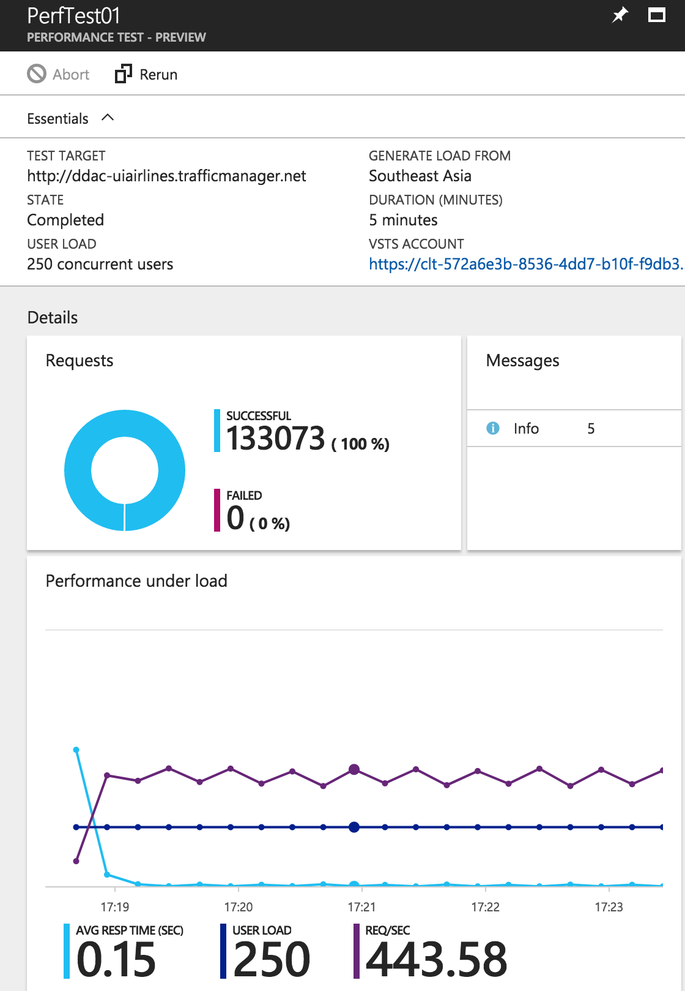

*Figure 20. PerfTest01*

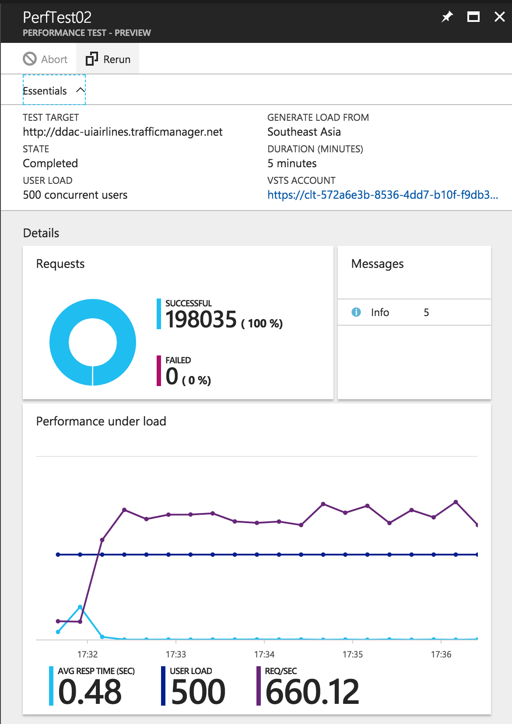

*Figure 21. PerfTest02*

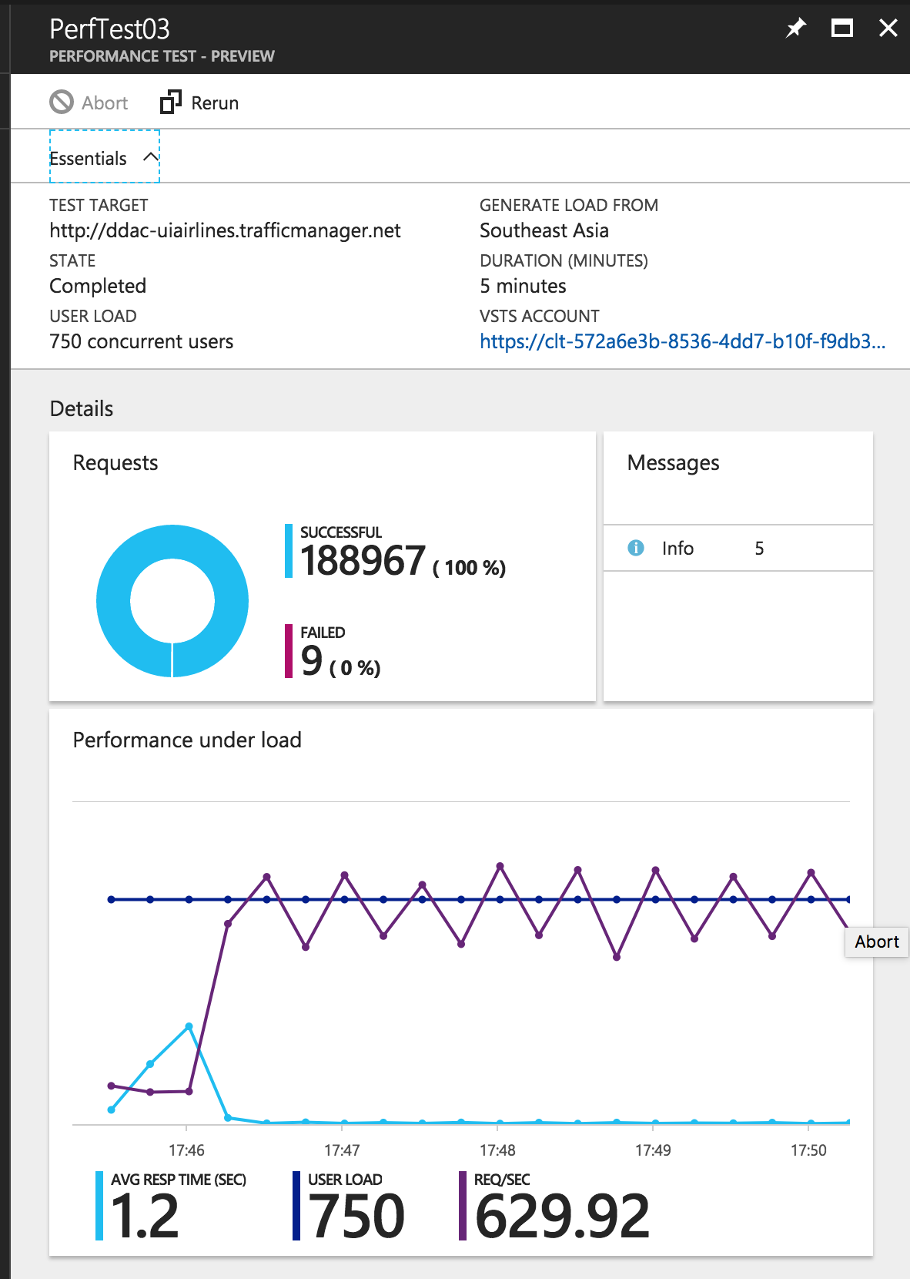

*Figure 22. PerfTest03*

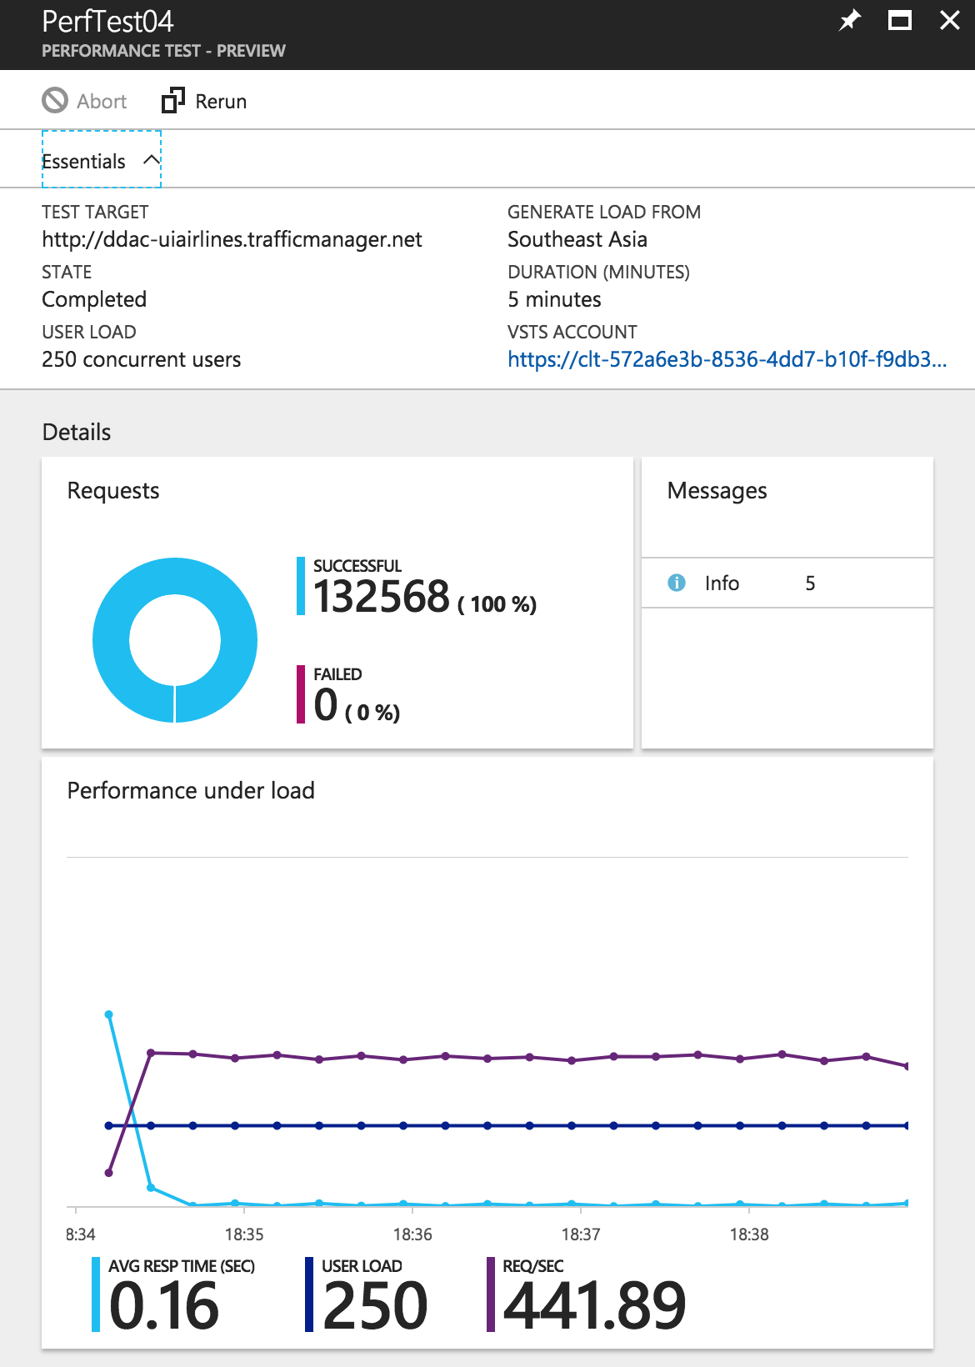

*Figure 23. PerfTest04*

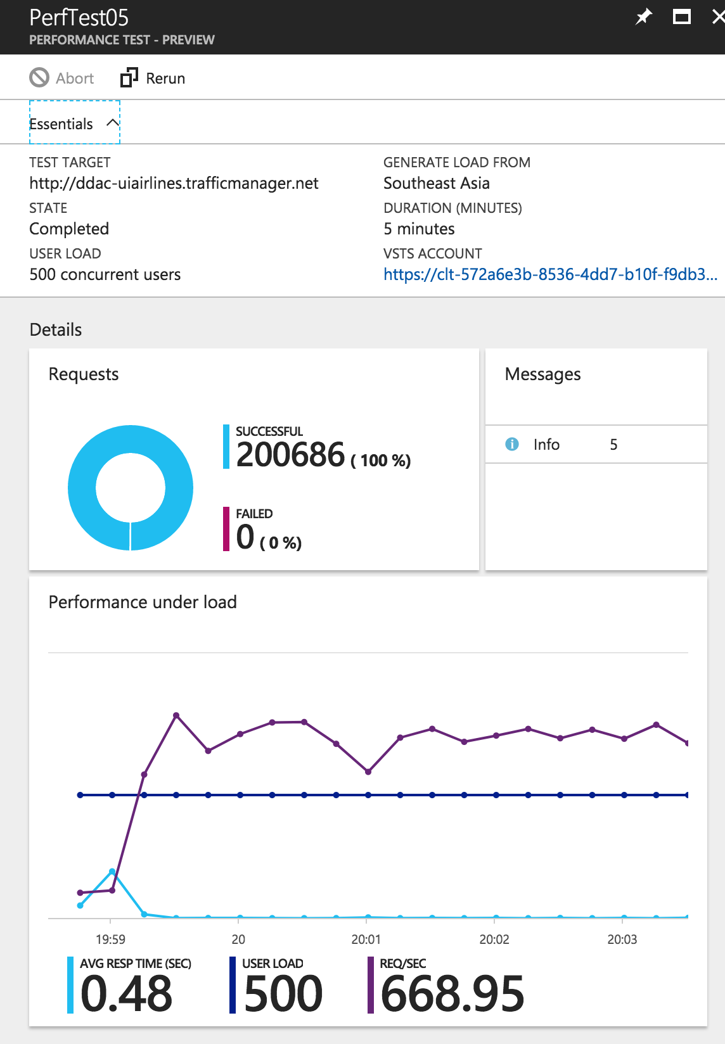

*Figure 24. PerfTest05*

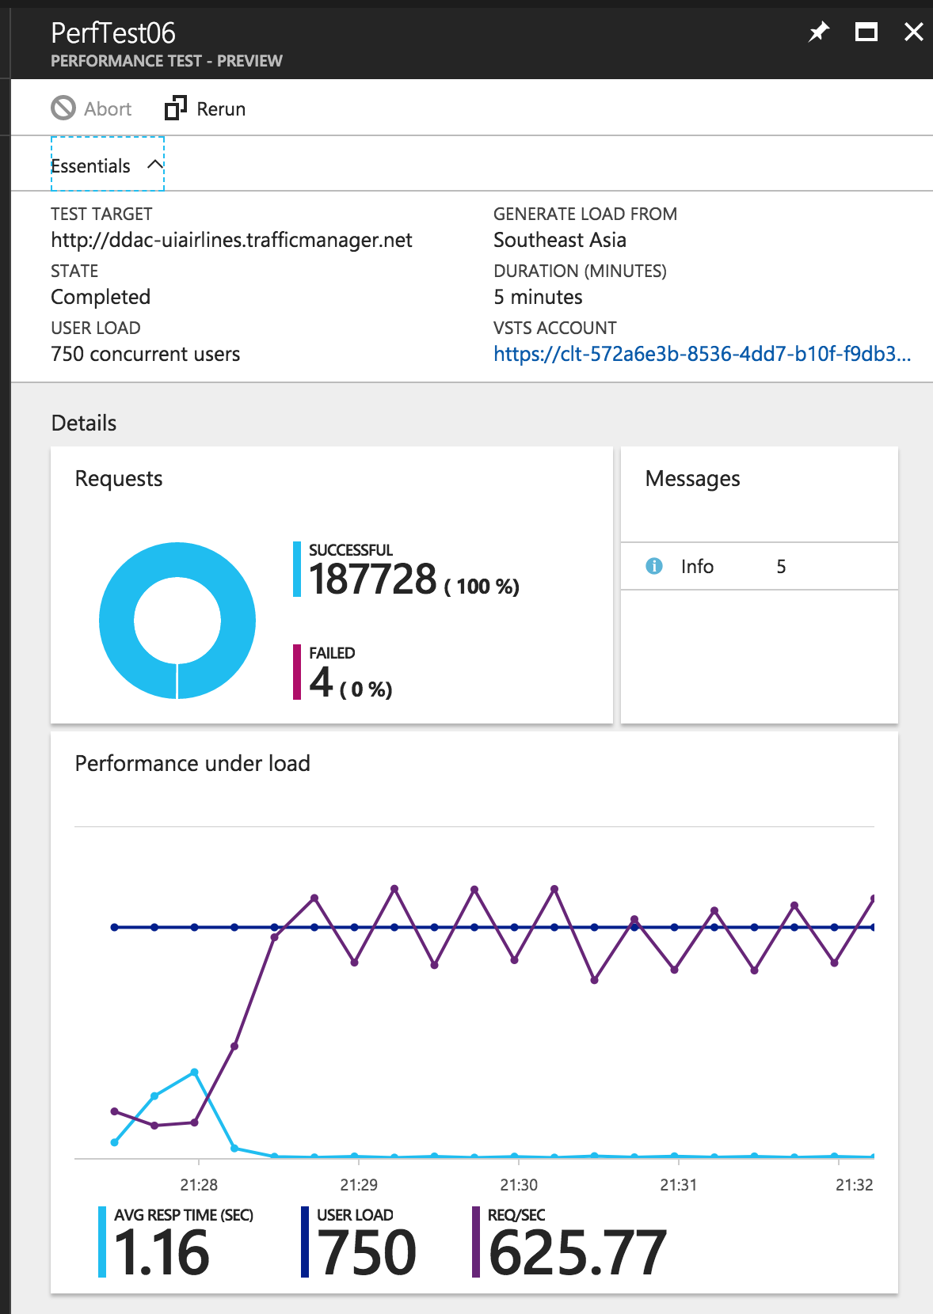

*Figure 25. PerfTest06*

### 5.1.2 Performance Testing Analysis

From the figures above, we can see that the system has an average response time of 1.16 and 1.2 seconds when there are 750 concurrent users on the system. Therefore, the system will be slowed down if there are more actual concurrent users, the company will have to look to optimize their code, or allocate more budget to the project for the system to run smoothly when there are more users. Another point is that when there are 500 concurrent users, the average response time in second shows 0.48 sec for both tests, which means the system is still usable.

# 6.0 Conclusion

To conclude, the development of an Online Flight Booking System for Ukraine International Airlines has been a success, but also a challenging process to deploy in Azure. The developer believes that this process of deployment to Azure will be also useful in the future. Except for deploying the system, the developer has also picked up new language such as MVC and the use of GitHub. There a plenty of advantages of hosting system on the cloud, it gives the ability such as: performance monitoring, testing and etc. Therefore, companies might decide to move to cloud solution for their applications for increased in performance and availability.

# 7.0 References

1. Microsoft, 2017. Traffic Manager Routing Methods. [Online]. Available at: <https://docs.microsoft.com/en-us/azure/traffic-manager/traffic-manager-routing-methods> [Accessed 7th October 2017]
2. Microsoft, 2017. Verify Traffic Manager Settings. [Online]. Available at: https://docs.microsoft.com/en-us/azure/traffic-manager/traffic-manager-testing-settings [Accessed 7th October 2017]
3. B. Tardif, 2013. Scaling Up and Scaling Out in Windows Azure Web Sites. [Online]. Available at: https://azure.microsoft.com/id-id/blog/scaling-up-and-scaling-out-in-windows-azure-web-sites/ [Accessed 7th October 2017]

# 8.0 Appendix

GitHub Repository: <https://github.com/ShanMen/DDAC-UIA>

Video Link: https://web.microsoftstream.com/video/53244bcc-95a9-4b7c-93b2-2dadcec60e5a?list=studio